M.M.F. Muzna

[REG NO: 722512424]  [SID:S22010447]

MINI PROJECT DOCUMENTATION [TASK 02] (EEI3346)

**TASK 02**

1.Front page

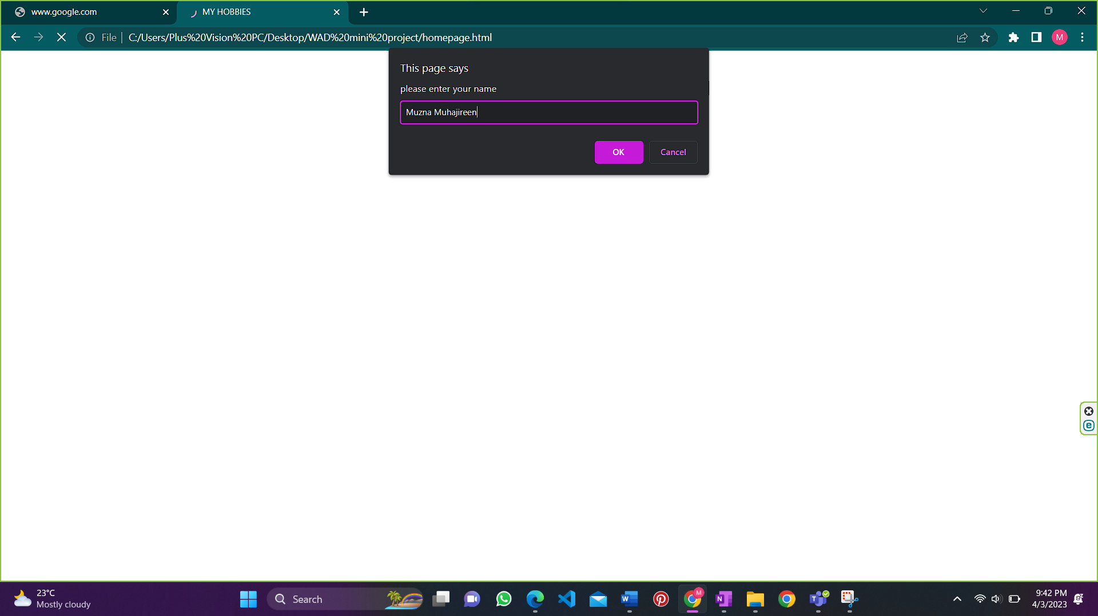

When you enter the website, you will get a pop-up message to enter your name. You can enter your name and the website will welcome you through the name.

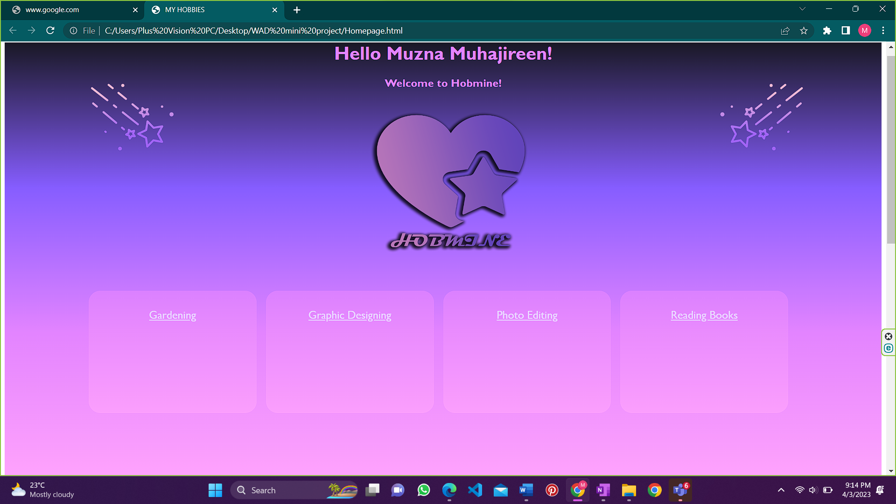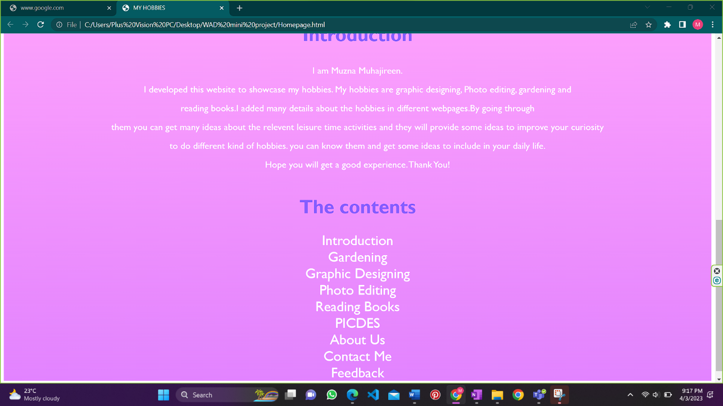

7.Test Results

**Gardening web page**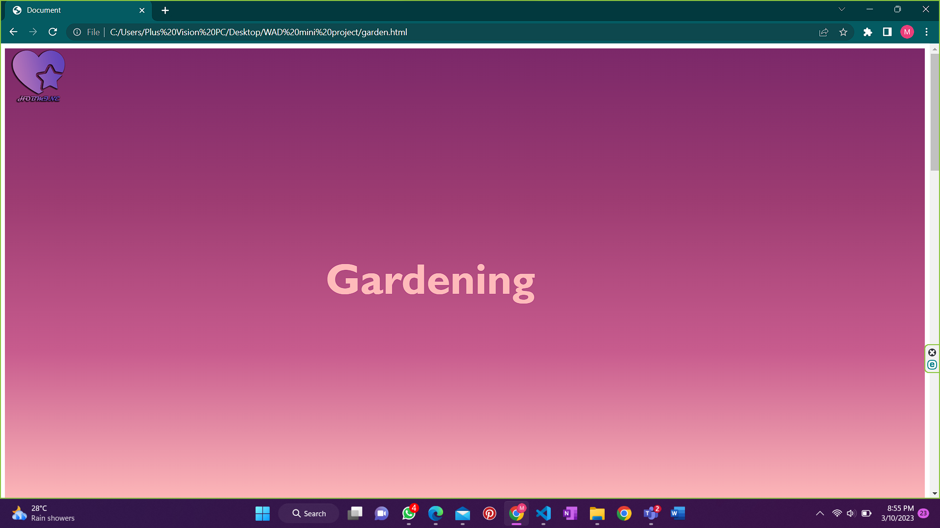

The Logo in the top-left corner of the page will go to the home page of the website. This applies for all the websites. And that is the official logo of the Hobmine website.

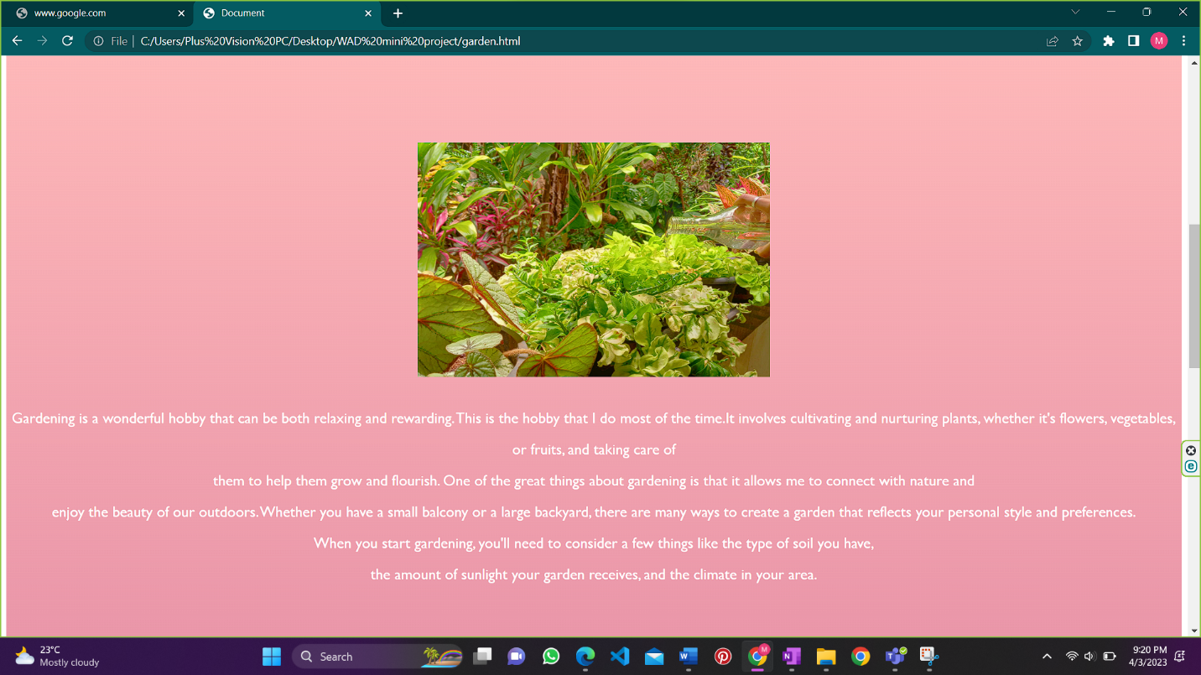

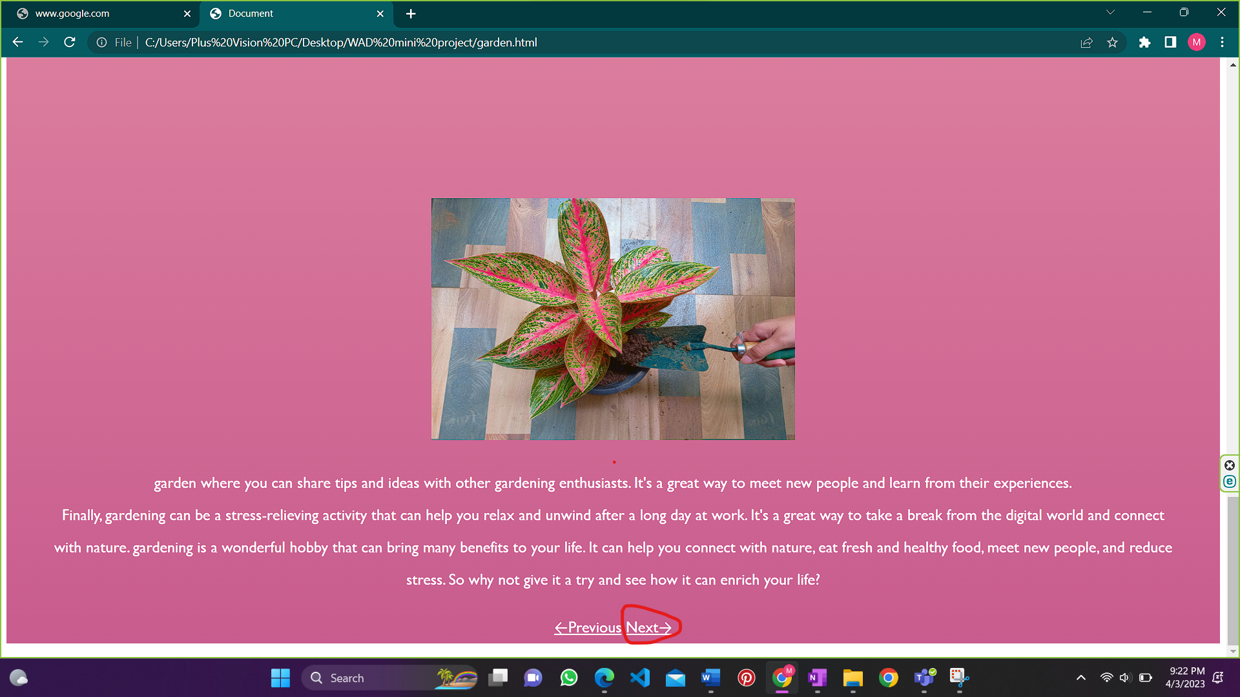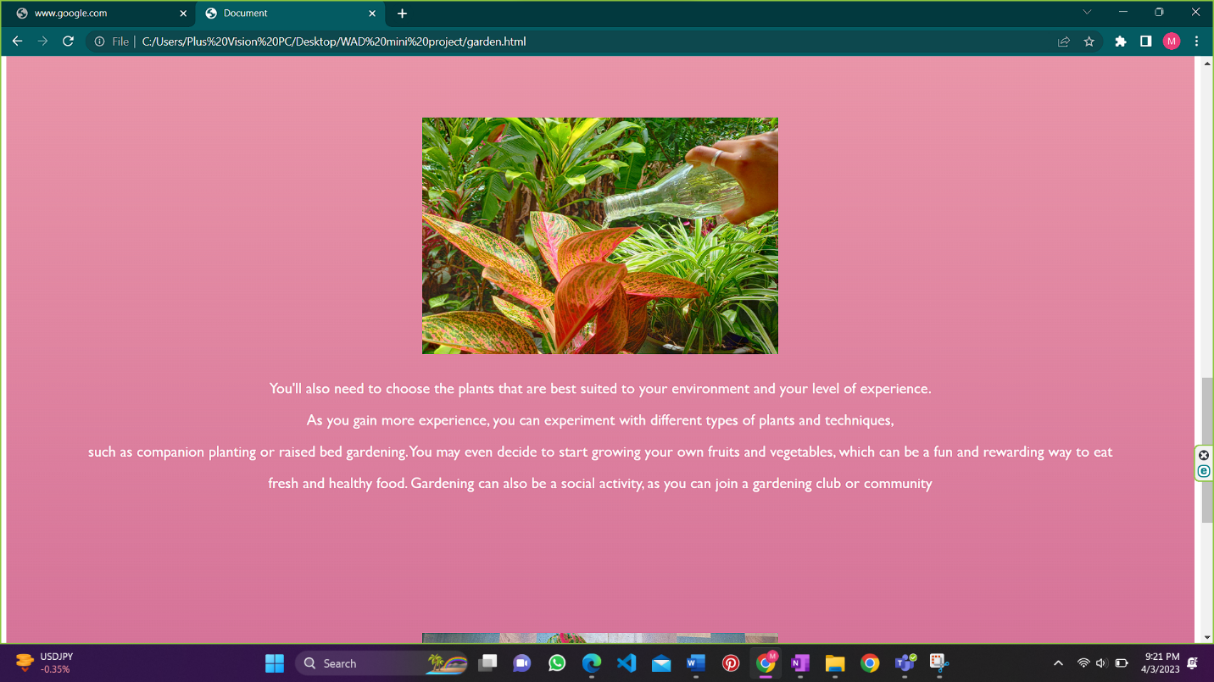

The **Next→** will be go to next age that is about my graphic designing hobby. And the **←Previous** will go to the previous page that is the home page of this website.

**Graphic designing web page**

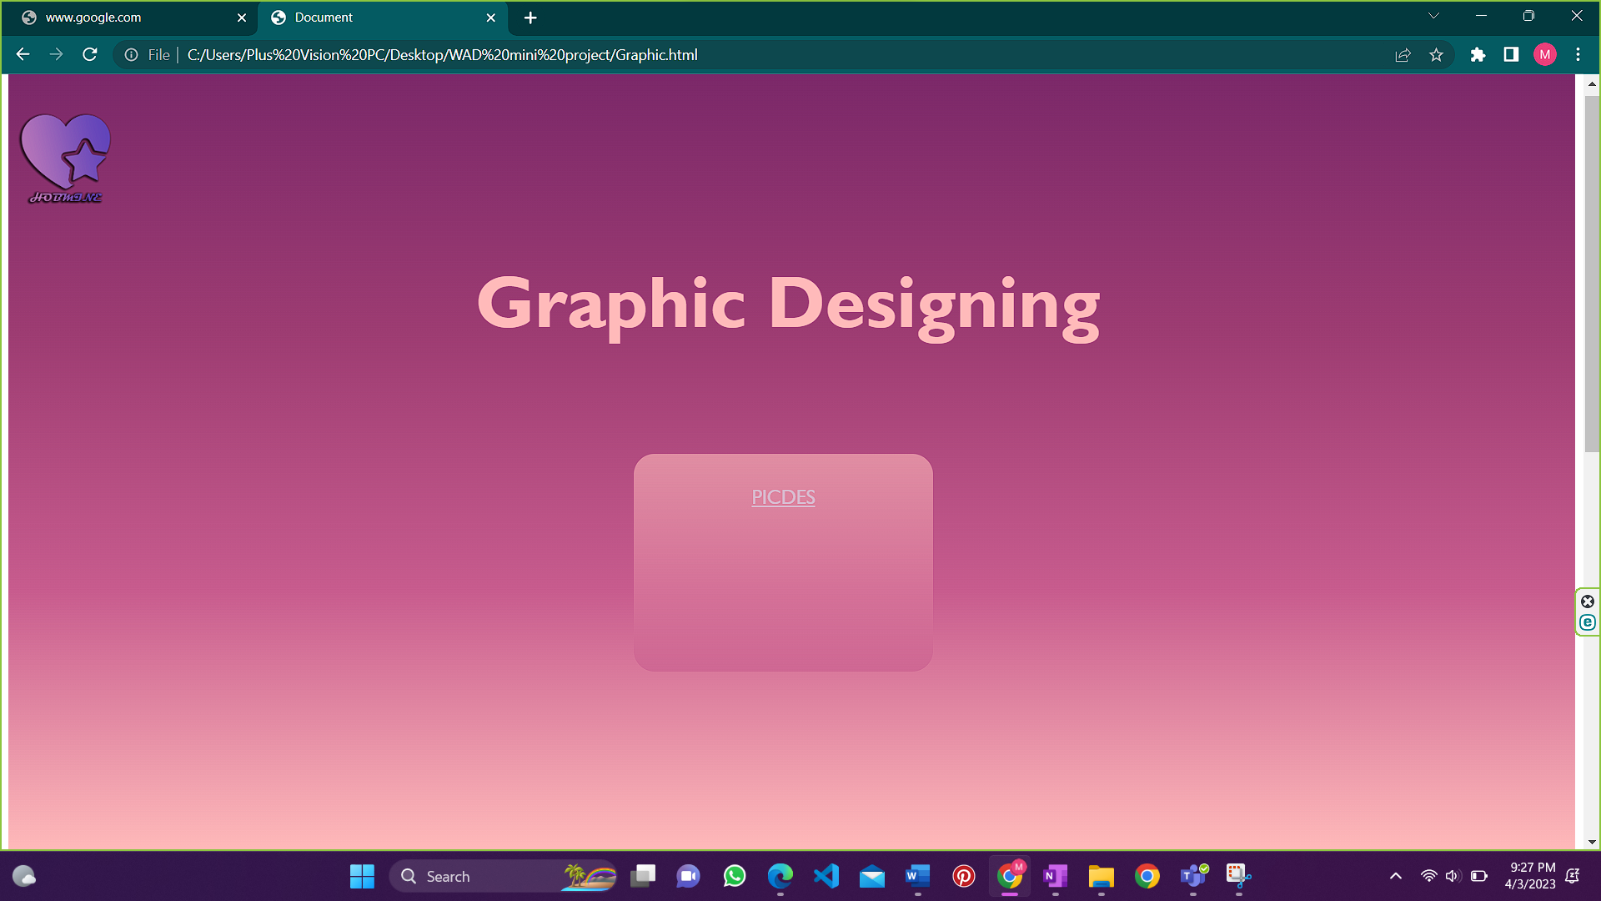

The PICDES link will be open the business-related information of mine.

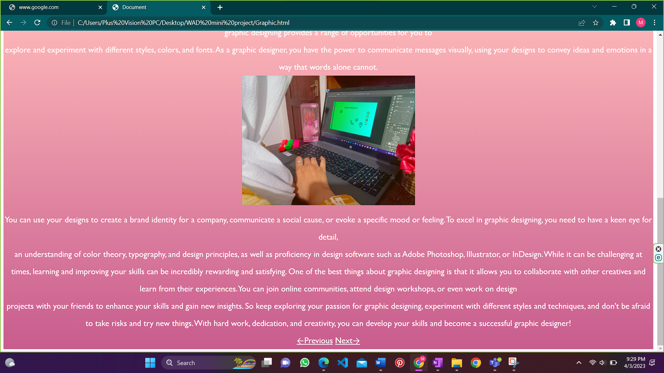

The **Next→** will be go to next age that is about my Photo editing hobby. And the **←Previous** will go to the previous page that is the gardening web page.

**Photo Editing web page**

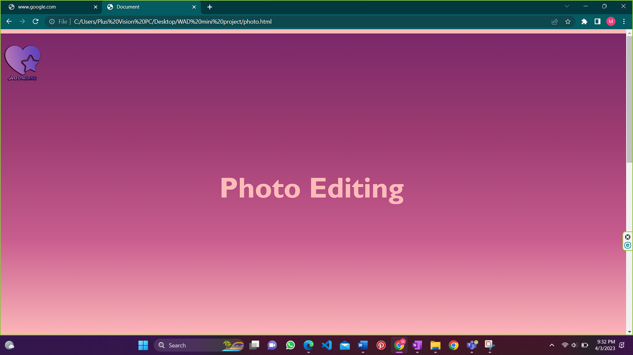

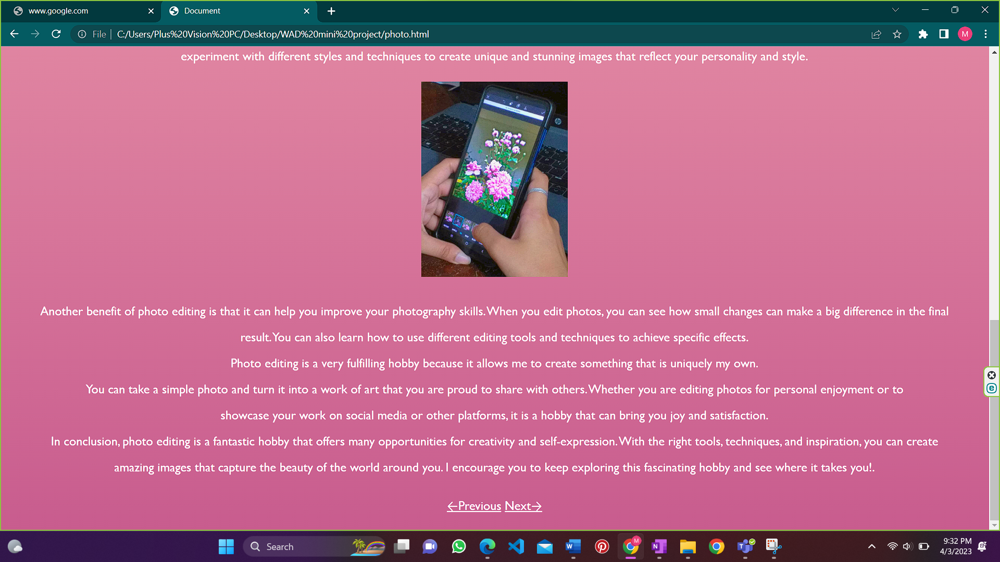

The **Next→** will be go to next age that is about my Reading books hobby. And the **←Previous** will go to the previous page that is the graphic designing web page.

**Reading Books web page**

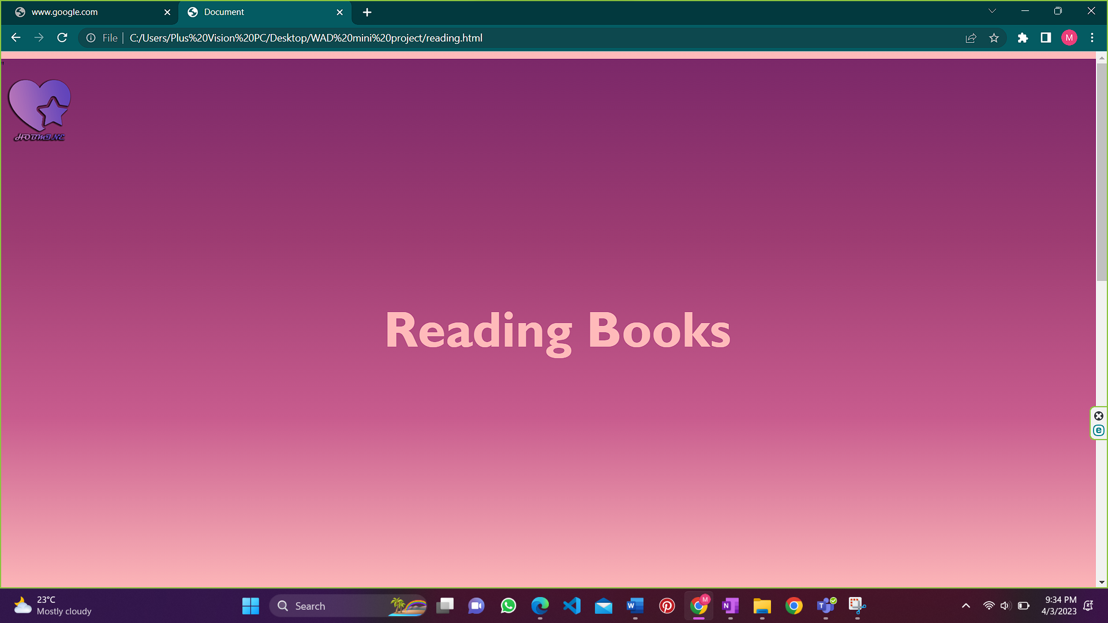

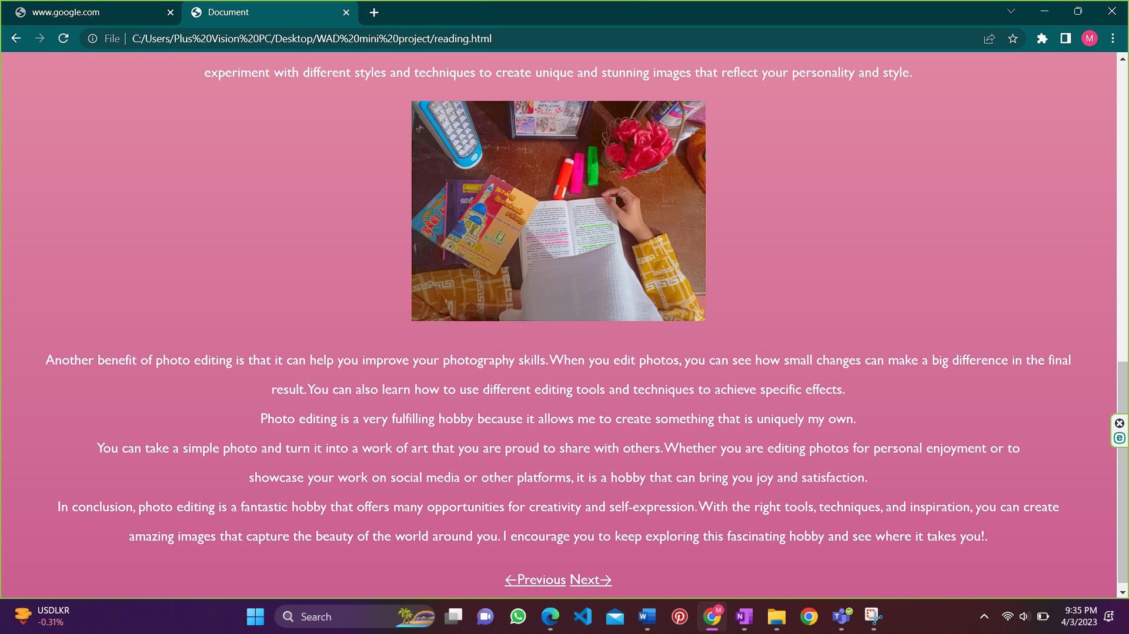

The **Next→** will be go to next page that is about my PICDES. And the **←Previous** will go to the previous page that is the Photo editing web page.

**PICDES web page**

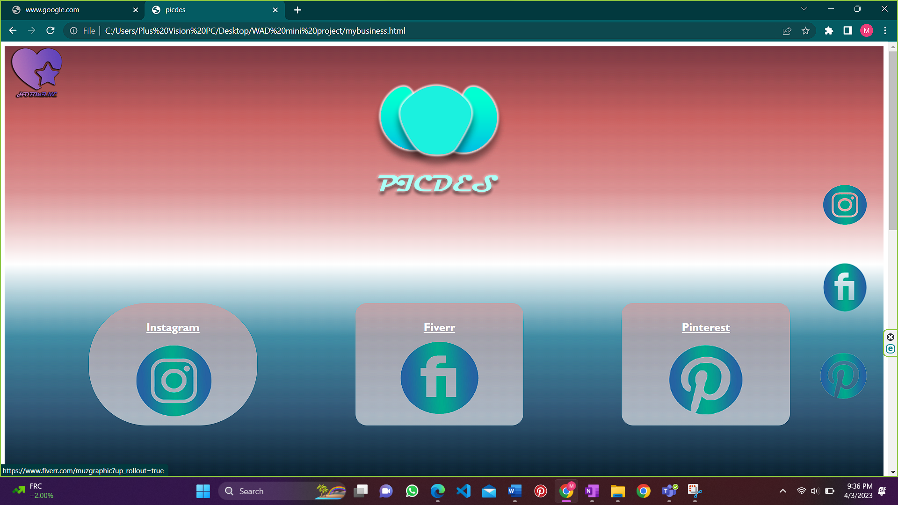

The Instagram, fiver, Pinterest link in the upper page and fixed In the right of the website will go to the relevant websites.

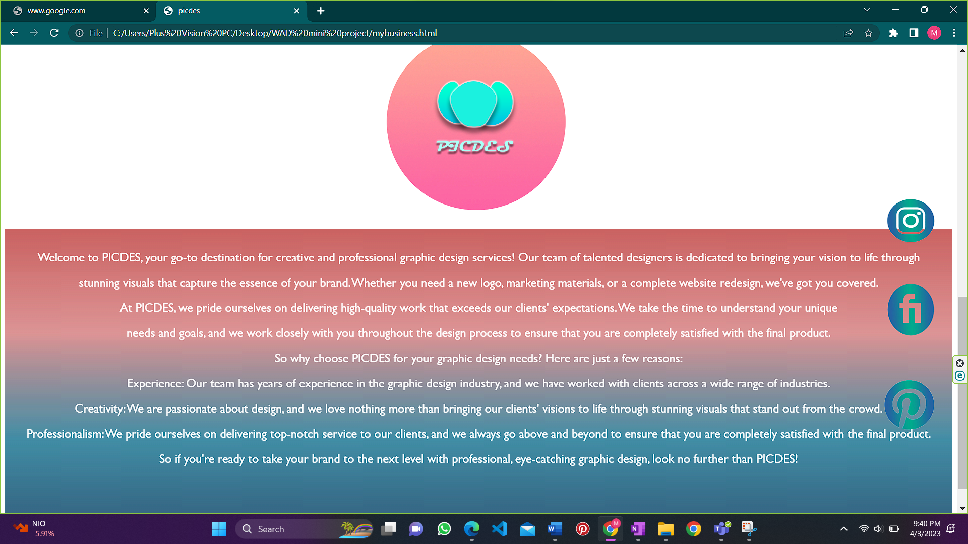

This web page is about my graphic designing business. viewers can get relevant details and give order through the destination links.

**About Us web page**

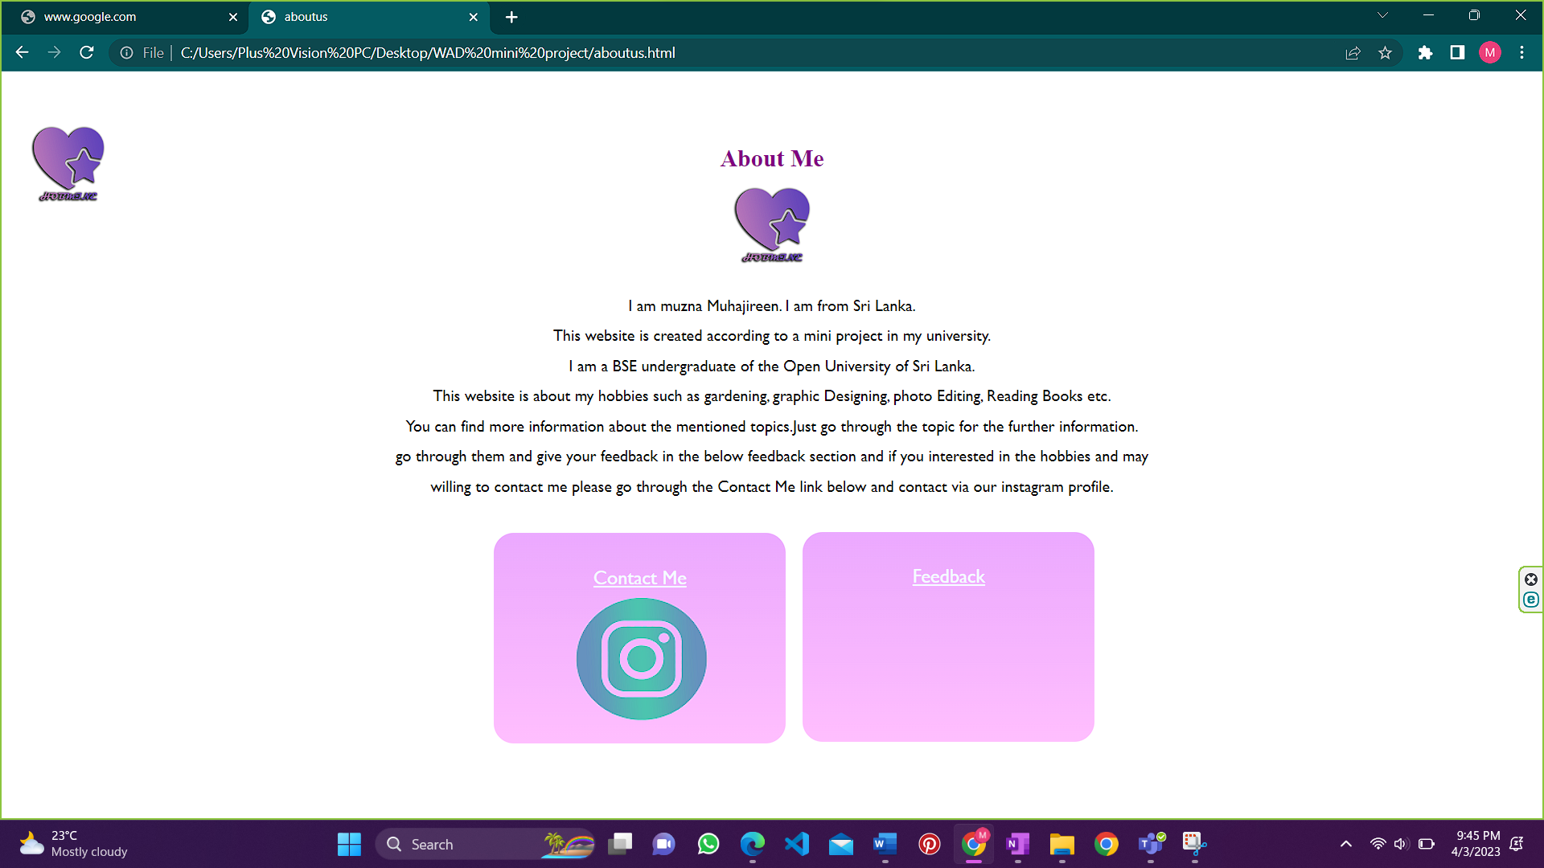

This page is about myself who the owner of this website. And I attached the feedback link and the contact details (**Contact Me**) here.

**Feedback web page**

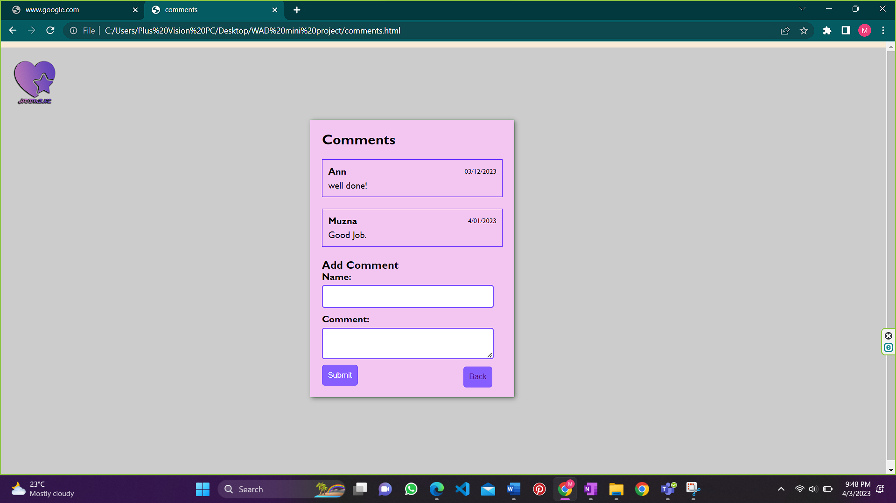Here the user can add their feedback about the website and other users can see the feedbacks.

|  |  |
| --- | --- |
| Problems | Solutions |
| I wanted to know some additional styling elements and tags to modify my website. | I learned them with the online tools |
| Designing two logos   1. Website logo 2. Business logo | I used Adobe Photoshop and Adobe illustrator to create them. And I created them by my own. |
| Designing the Fiverr, Instagram, and Pinterest logos and creating them in the same color format as I wished. | For this also I used Adobe Photoshop to create them. |
| Wanted to create a colorful and attractive website. | I Chose some beautiful color palettes and fonts and some icons to create them attractive. |
| Bugs and errors | Identified the corrected the mistakes. |

2.), 3.) Problems and Solution Approach

4.Architectural diagram of the system

Graphic Designing Photo Editing Gardening Reading Books

Home Page

(Hobmine)

Inside this↓

Introduction contents

1.Graphic Designing

2.Gardening

3.Photo Editing

PICDES 4.Reading Books

About Us 5.PICDES

Instagram 6. About Us

Feedback 7.Contact Us

8.Feed Back

5.Site Map

Introduction

Table of contents

HOME(HOBMINE)

Gardening

Gardening

Graphic Designing

PICDES

Feedback

Contact Us

PICDES

Photo editing

Feedback

Contact Us

About Us

Photo editing

Reading Books

About Us

Reading Books

Graphic Designing

Web Page Link Content Destination

6.Used web technologies and examples

* HTML
* JavaScript
* CSS
* Vue

8. Conclusion

This website’s name is Hobmine and the logo of the web is given above. In all the web page’s top-right corner this logo is fixed that is a destination link to the home page. And this website will give the relevant ideas of the 4 hobbies such as gardening, graphic designing, photo editing, reading books. Overall, I believe that this website is colorful, attractive and describe the professionalism.